**3D- BUILDER MODULE**

1. Click Tools and then Setup and follow the instructions.

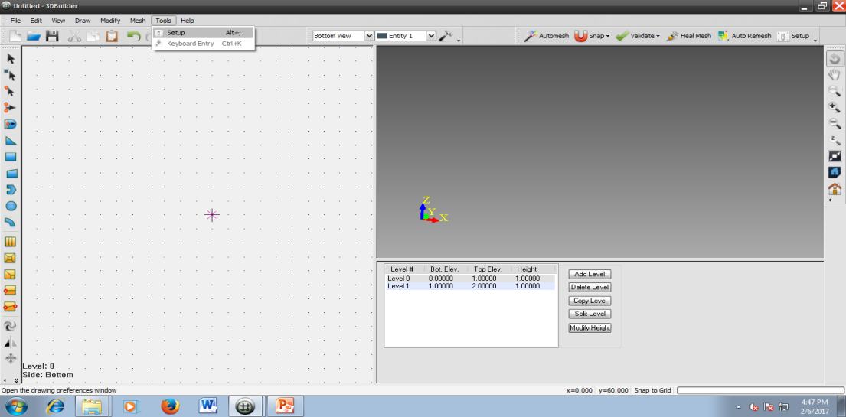

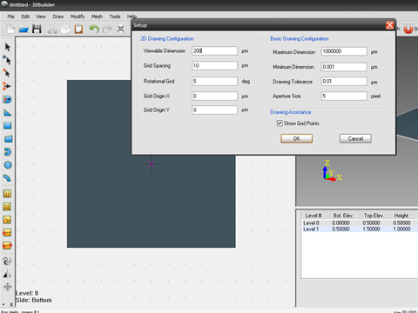

1. On the right panel, click on level 0 and select modify height and enter 0.5. Press ok

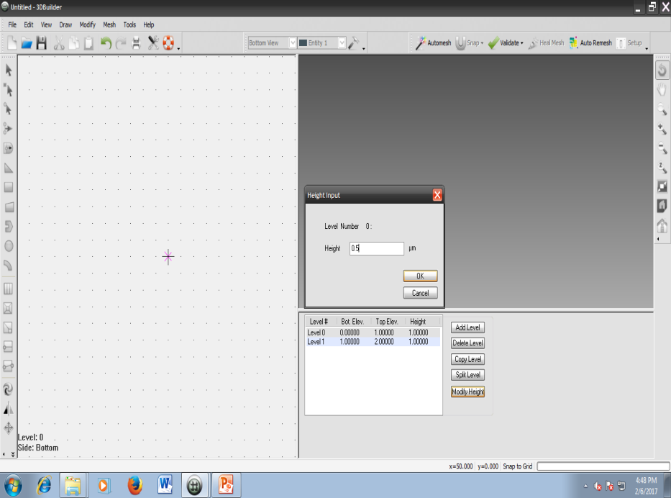

1. Click rectangle and select Tools 🡪 Keyboard entry. Enter (-50,-50) and (50, 50).

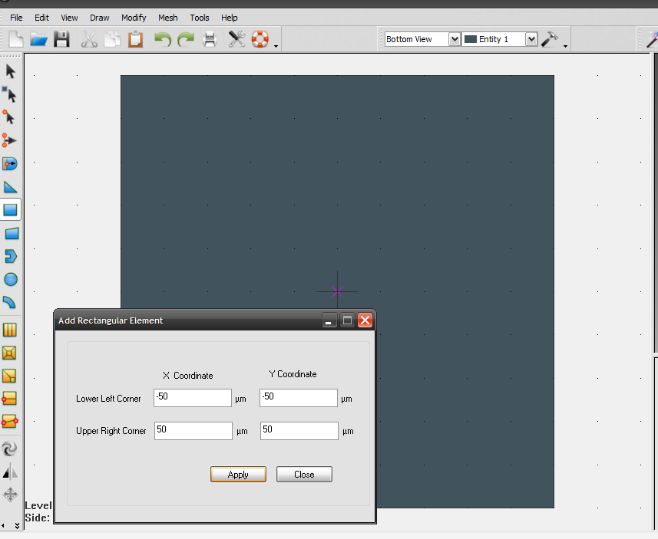

1. Similar to step 2 click on level 1 and modify height and enter 0.5.
2. Modify the entity and select entity 4.

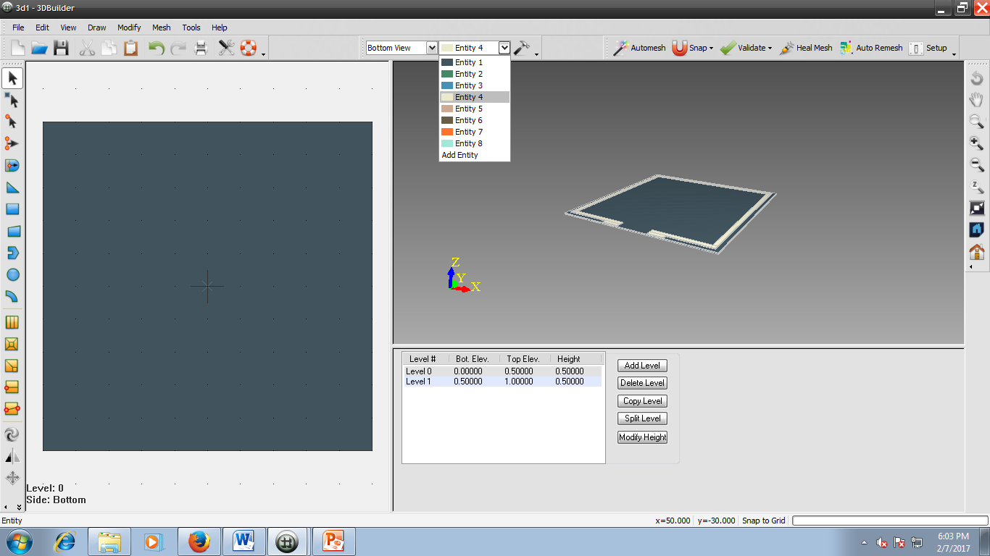

1. Now click rectangle and follow the instructions. Two coordinates are (-20,-50)and (-10,-47.5)

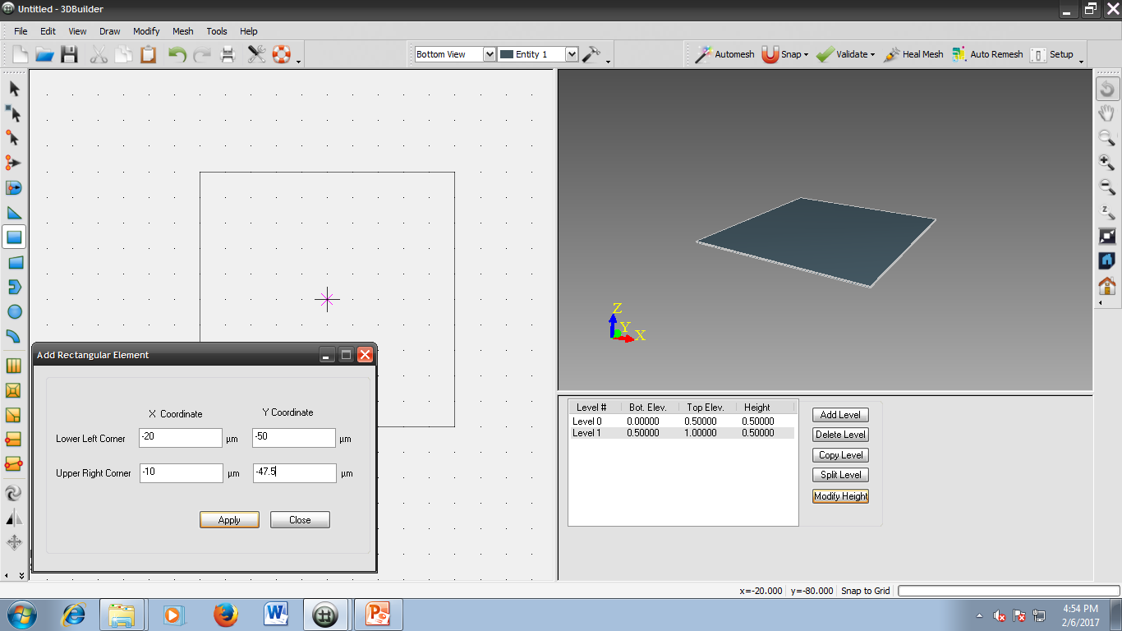

1. Now click rectangle and follow the instructions. Two coordinates are (-10,-45) and (-47.5,-47.5).

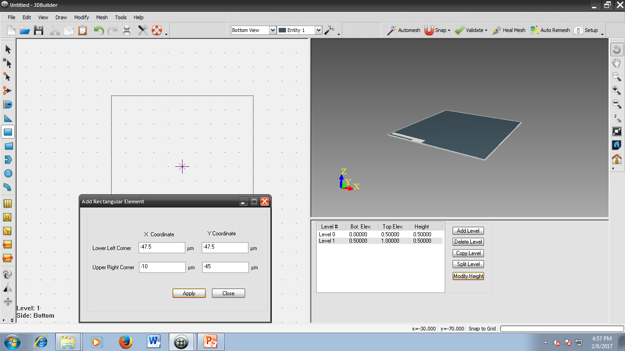

1. Click rectangle and follow the instructions. Two coordinates are (-47.5,-47.5) and (-45,47.5)

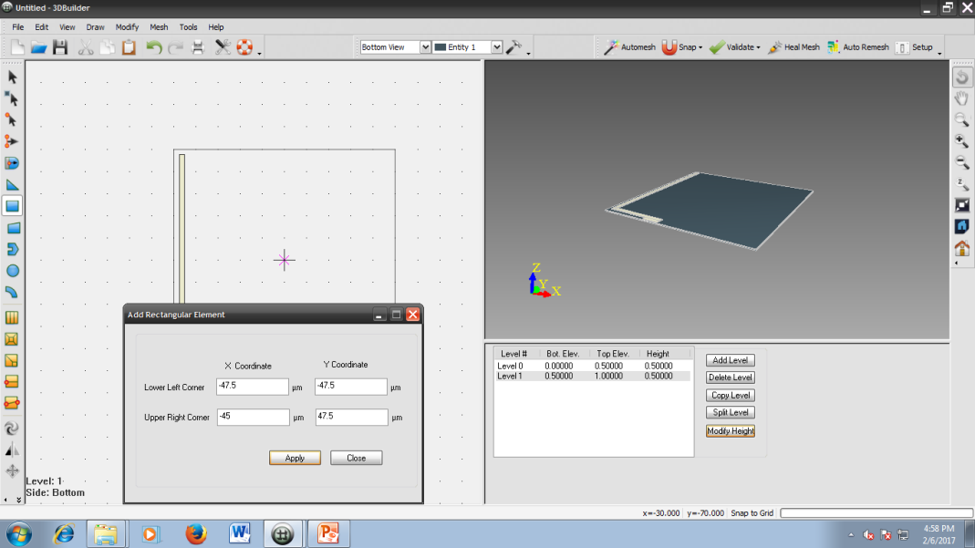

1. Select the last 3 rectangles drawn and click on mirror and then click Tools🡪 Keyboard entry

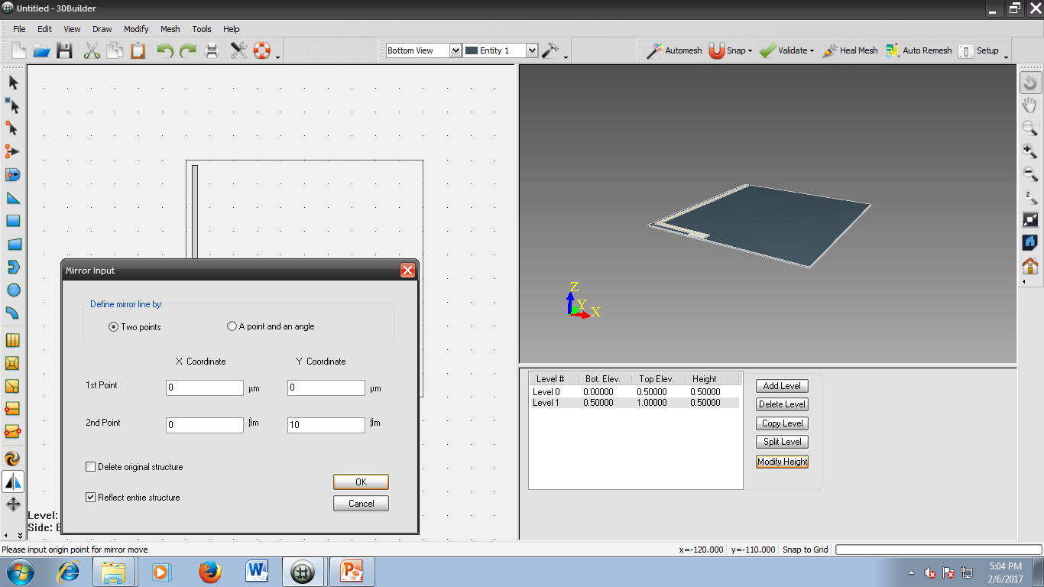

You should get a figure as shown below.

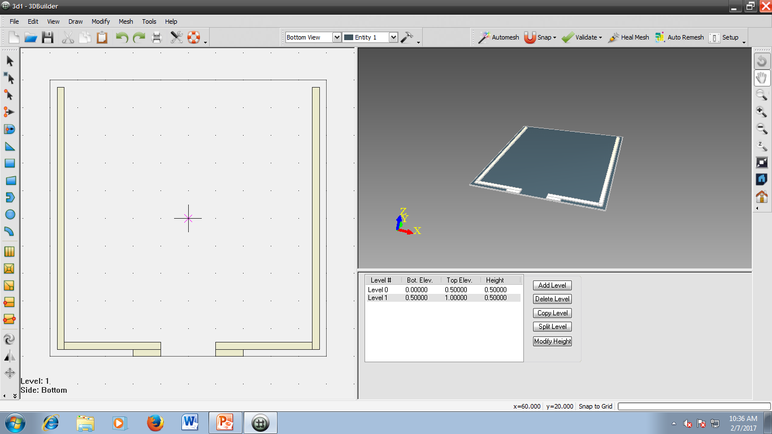

1. Click rectangle and give the two coordinates (-47.5, 47.5) and (47.5, 45).

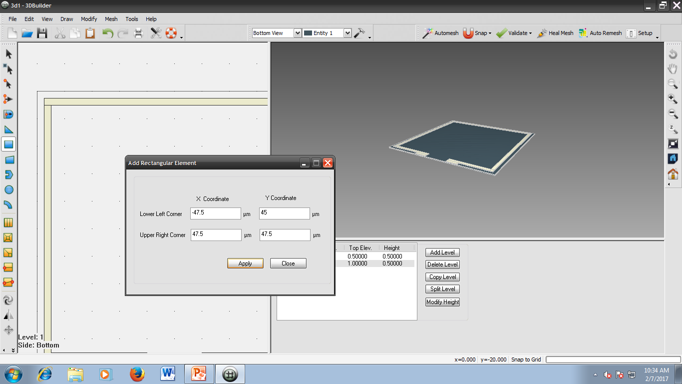

1. Click Mesh 🡪 Validate mesh connectivity. This checks for overlapped elements.

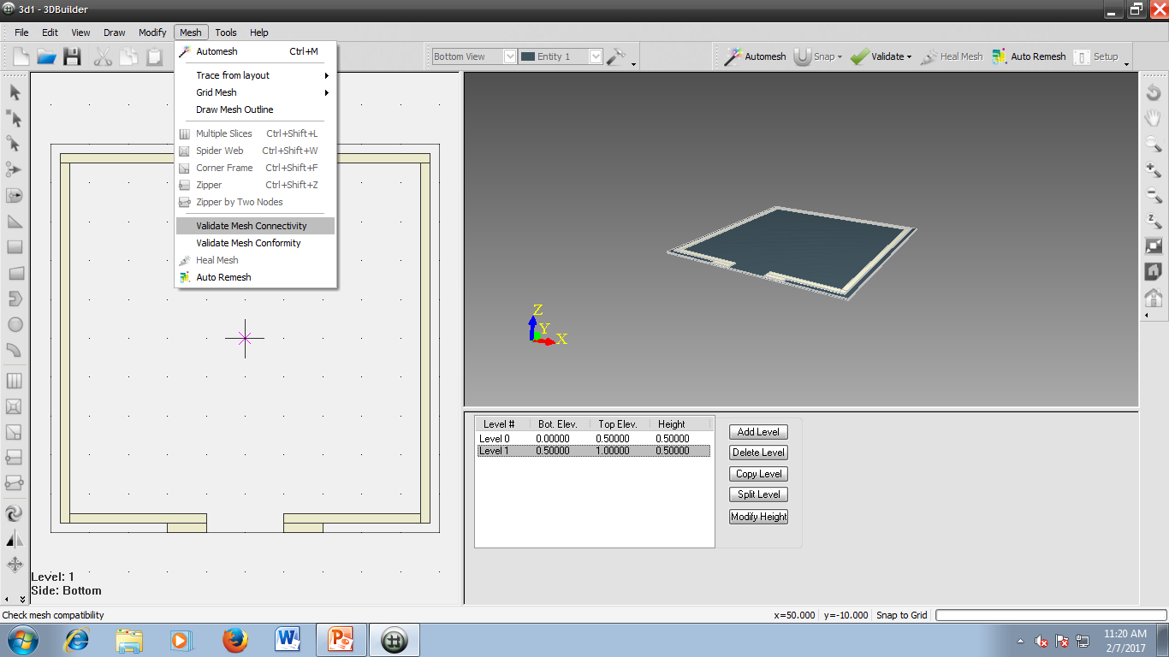

1. You will have some misaligned elements.

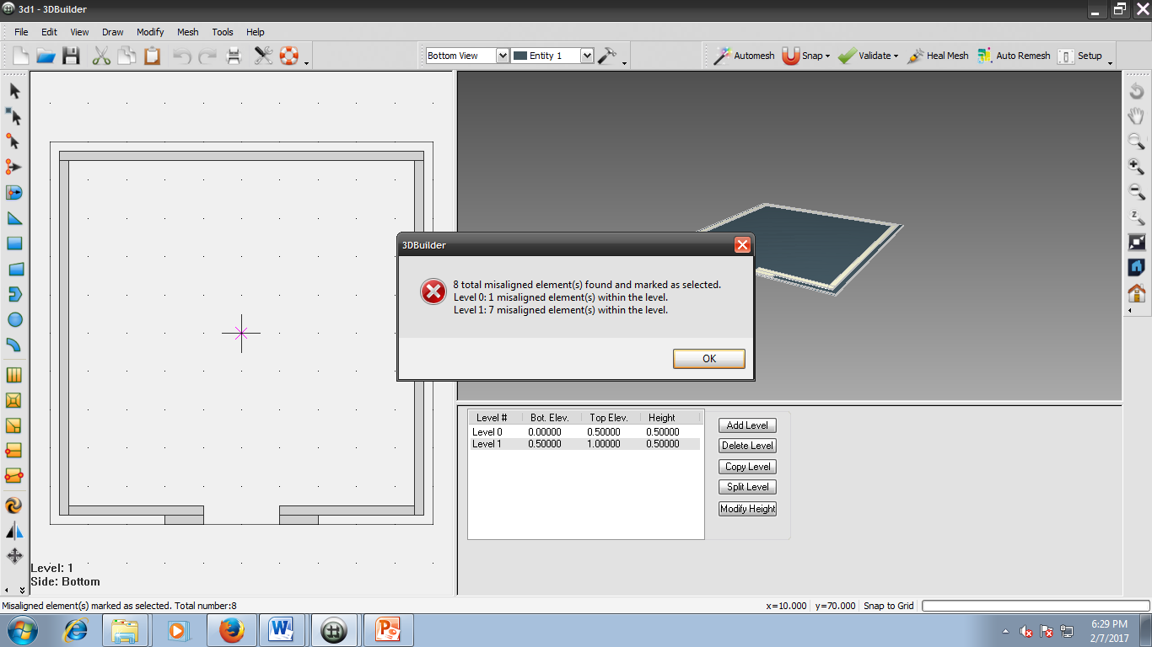

1. Similarly Click Mesh 🡪 Validate Mesh conformity. You will have no illegal elements.
2. To solve the error at step 12, select Mesh🡪 Auto mesh and give mesh size of 30.

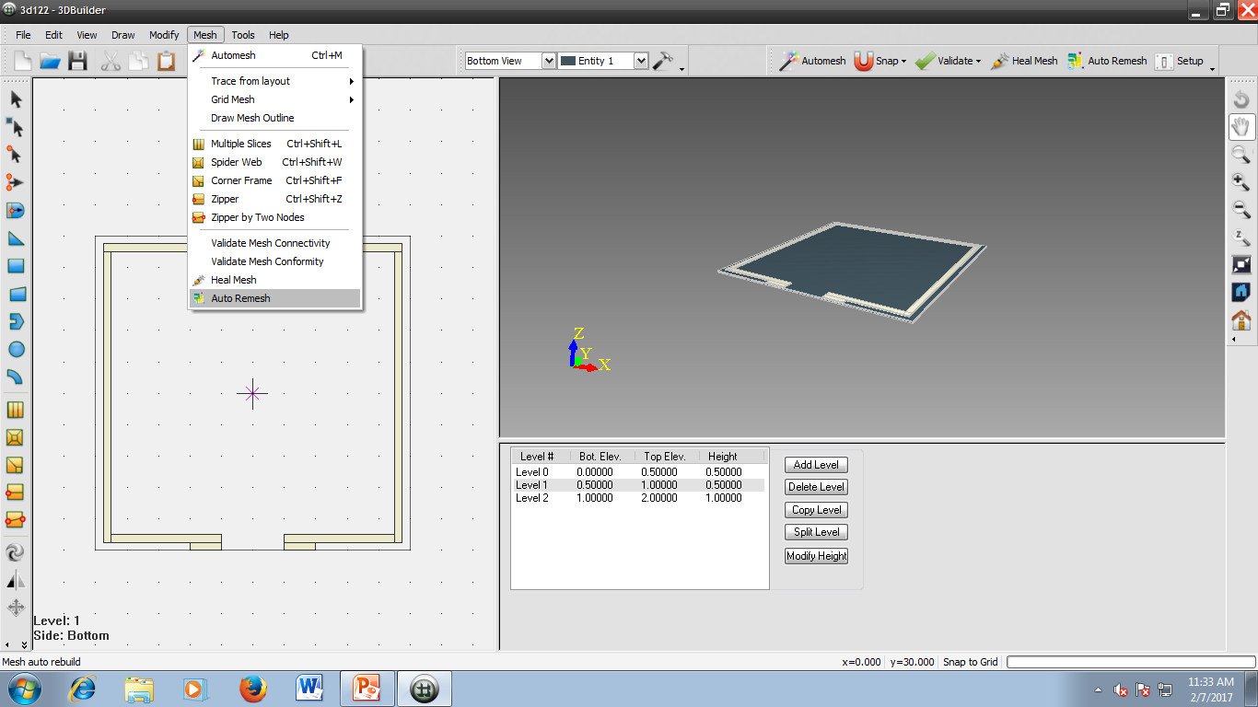

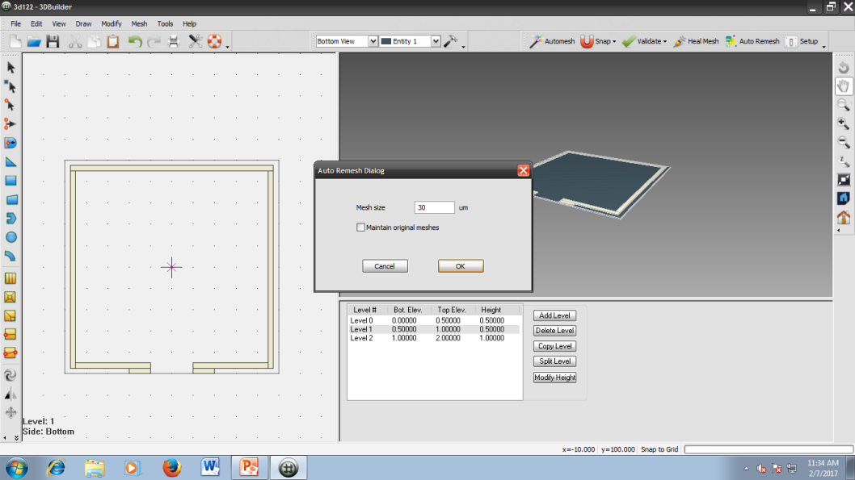

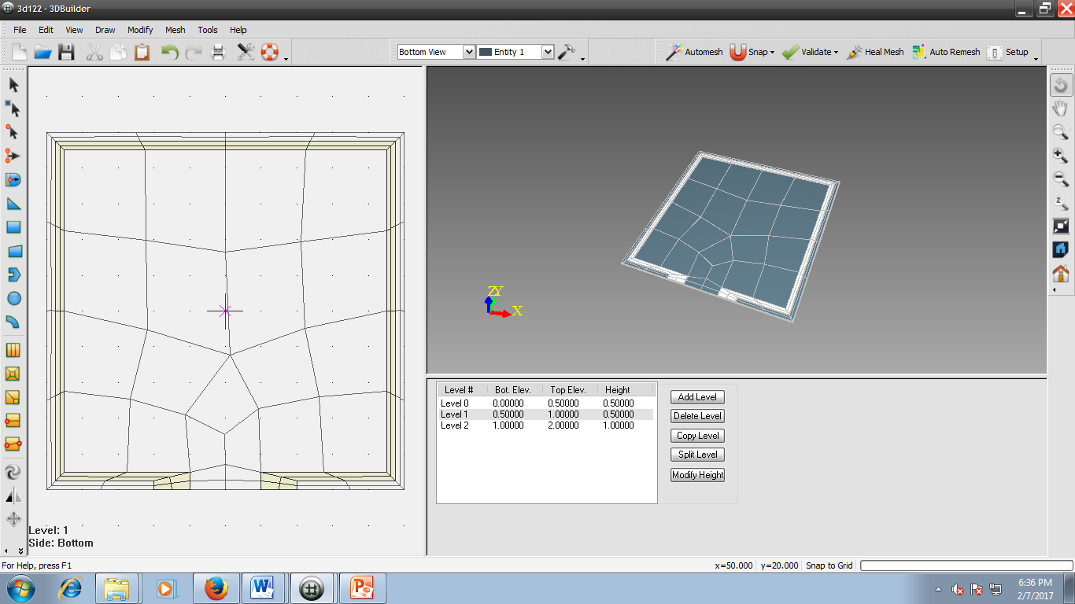

1. Now Click File and Export to Analysis Module. At that time, the builder will ask to check for mesh validity and now you will find no illegal or misaligned elements.